**Analysis and exploration of climate change data from World Bank**

**Abigith Benson Benzigar**

GIT Hub repository: <https://github.com/Abiben100/ADS1-Assignment-2.git>

For the report on analysis of climate change 10 of different countries were selected based on environmental and demographic indicators for selected countries, including China, India, United Arab Emirites, Brazil, Cuba, Spain, United Kingdom, Greece, Israel, Nigeria. The indicators include forest area, arable land, co2 emission, and total population of each country. This analysis aims to uncover trends, patterns, and potential correlations over the years.

In this analysis the correlations and causes were found and stated in the report.

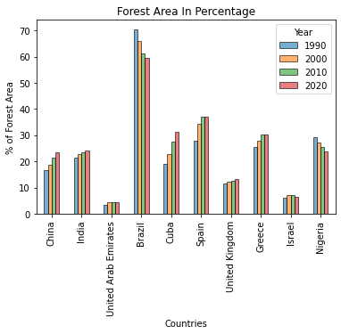®

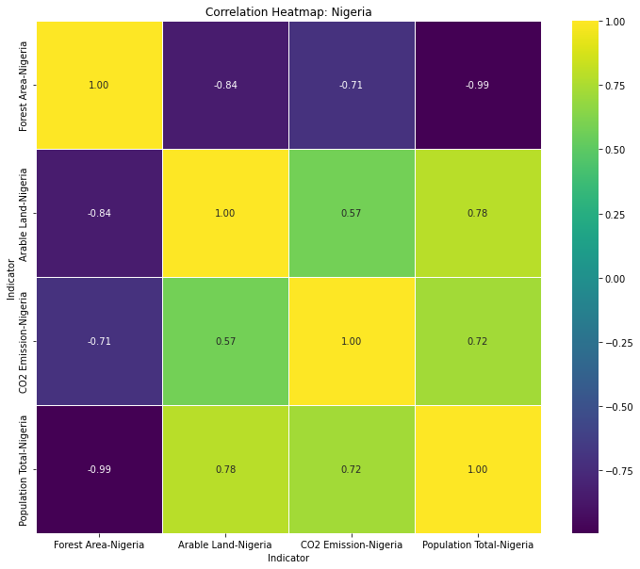The statistical properties of the forest area data were explored. The study analysis of forest area data across selected countries, revealing that Brazil covers 70% of its land with forests, reducing over time to 60% by 2020. China, with a larger land mass, has only 18% forest area, increasing to 25% by 2020. India and China share similar percentages, while Cuba has a higher forest area of around 35%.

The heatmap of Nigeria reveals a significant negative correlation between population and forest area, with population significantly impacting CO2 emissions and deforestation, leading to arable land creation.

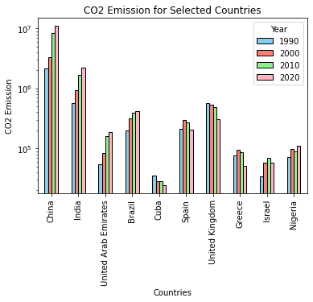

The bar plot shows the co2 emission of the countries China and India is large due to the large economy and the industries while Cuba has a lot of forest they have less co2 emission and UAE produces a lot of co2 as the natural ecosystem is desert they have less vegetation but it is the 3rd highest co2 producer of the selected 10 countries.

**Table for Summary stats on arable land:**

|  |  |  |  |
| --- | --- | --- | --- |
| Country | STD | Median | Max |
| China | 0.45789348 | 12.72438322 | 13.3012 |
| India | 0.92611349 | 53.49574027 | 54.9776 |
| UAE | 0.14756564 | 0.630808223 | 1.05604 |
| Brazil | 0.57836415 | 5.817502459 | 6.96958 |
| Cuba | 2.49807569 | 32.53724395 | 35.6988 |
| Spain | 2.23894134 | 25.6798348 | 30.7043 |
| UK | 0.97764929 | 24.9799268 | 27.3632 |
| Greece | 2.06178816 | 20.2211016 | 22.4903 |
| Israel | 1.38631764 | 15.5036968 | 17.8835 |
| Nigeria | 2.69451486 | 39.3052032 | 40.4844 |

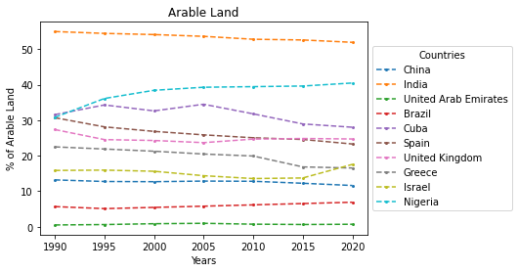

The line plot shows the data of the arable land in a line plot overtime, Nigeria have a rapid growth from 30 percentage to 40 percentage in 30 years which shows Nigeria have a rapid increase in the arable land which also means there is potential deforestation risk associated to the country which leads to climate change, US, Brazil and China have about the same amount of arable land for the past 30 years. There is a sharp increase of arable land in Israel from 2015 to 2020 about 5 percentage increase. Spain, Greece and India have reduced arable land, which can mean that there is forestation and also mean industrialization on arable lands.

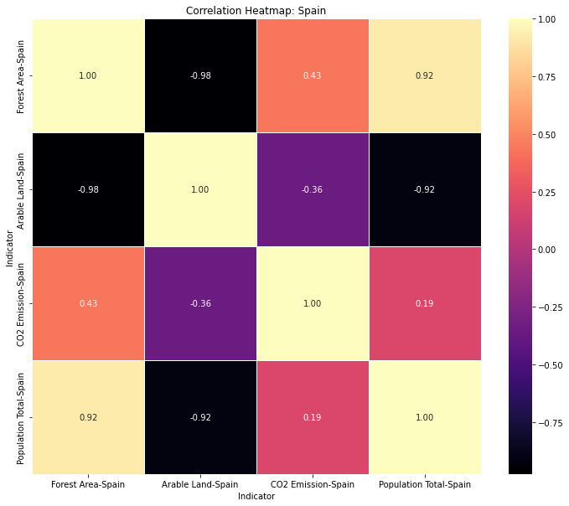

The heatmap of Spain gives a detailed data of all the indicators of Spain which gives a lot of information, from the heatmap forest area and population have a negative correlation with arable land which means that when the population increases the arable land is most likely cleared for residential lands.

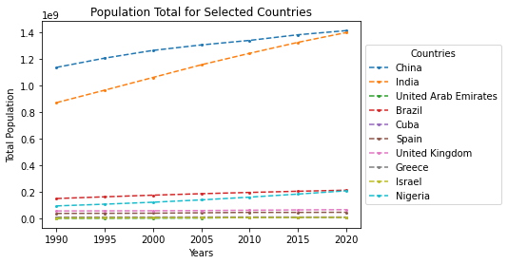

In the line plot for the total population China tops the population but India caught up to the Chinese population by the year 2020, which means China and India contribute much on a large scale for climate change than the rest of the 10 countries. The population of Nigeria have gone up by a notch after 2000 to 2020. Israel Greece and UK have pretty much stable population from 1990 to 2020. Brazil shows a slight change in the population. China and India play a major role in the population crisis which is a leading cause for climate change.

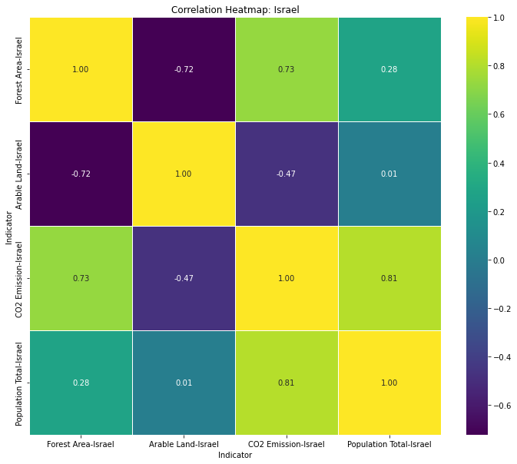

From the heatmap plot we can get that the arable land of Israel and population have a neutral correlation stating that the population is not a serious problem for Israel, co2 emission have a strong positive correlation to population. Forest area is negatively correlated to arable land, which states that the increase in arable land is associated with decrease in forest land in Israel which contribute to climate change.